HOLY LAND

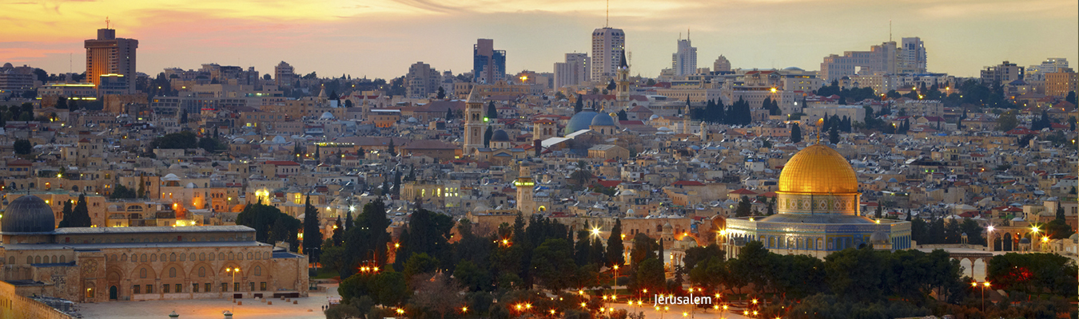

Jerusalem • Bethlehem • Nazareth • Galilee • Via Crucis • Last Supper • Gethsemane • Dormition • Nativity Church • Capernaum • Tel Aviv

Trips in 2019 - $4,000.00
Mar 02-12 Mar 20-30 Apr 03-13 Apr 10-20 Apr 17-27 Apr 24 - May 04
May 01-11 May 08-18 May 15-25 May 22 - Jun 01 May 29 - Jun 08
Jun 05-15 Jun 12-22 Jun 19-29 Jun 26 - Jul 06 Jun 29 - Jul 09
Aug 28 - Sep 07 Sep 04-14 Sep 11-21 Sep 18-28 Sep 25 - Oct 05
Oct 02-12 Oct 09-19 Oct 16-26 Oct 23 - Nov 02 Oct 30 - Nov 09
Nov 04-14 Dec 02-12 Dec 18-28

Trip Itinerary
Day 1: Depart from USA. Arrival next day.
Day 2: Arrive at Tel Aviv Ben Gurion Airport. We will meet our guide and head to our hotel by deluxe motor coach. We will have a brief orientation meeting, enjoy a meal, and acclimate to our new surroundings. Dinner and overnight in Jerusalem.
Day 3: After breakfast, we shall view the Place of the Ascension before we descend by foot and visit the Pater Noster Church commemorating Jesus' teaching His disciples the Lord's Prayer. Then we will walk down to the church of Dominus Flevit; here Jesus wept over the City of Jerusalem and foretold its destruction (Luke 19:41-44). We shall then visit the Garden of the Gethsemane, the scene of Jesus' agony, betrayal and arrest (Luke 22:22-54). Also visit the Church of All Nations containing the rock where Jesus is believed to have prayed before His betrayal and arrest, after lunch, visit the Upper Room, the site of the last supper. Then continue to visit the Dormition Abbey, built over the site where the Virgin Mary was laid to rest its name meaning eternal sleep. Proceed to the Church of St. Peter in Gallicantu, which is built over the site of the house of the High Priest Caiaphas and the dungeon where Our Lord was imprisoned before his trial. It is also here that Peter denied knowing Jesus thrice (Luke 22: 54-62). Dinner and overnight in Jerusalem.
Day 4: After breakfast, we will visit Bethlehem starting with the Basilica of the Nativity and the Grotto, venerated as the birthplace of Jesus (Luke 2:1-7). Also visit the Church of St. Catherine, the Crusaders' Cloister, the Chapel of St. Jerome and the Grotto of the Holy Innocents. Continue to visit the Shepherd's Fields (Luke 2:8-20). After lunch in Bethlehem we shall drive to Ein Karem, home of St. Elizabeth, and mother of John the Baptist to visit the Church of the Visitation and the Church of St. John the Baptist. Enjoy a night tour of Jerusalem. Dinner and overnight in Jerusalem.
Day 5: Today we shall drive to Jericho to view the Old City and the Mount of Temptation. We shall also view Zacchaeus' tree. Proceed to Qumran - ruins of the ancient Essene settlement in whose nearby caves the Dead Sea Scrolls were discovered; take the cable-car to the top of Masada - the scene of the epic stand by the Jewish Rebels at the end of the Great Revolt against Rome nearly 2,000 years ago; and enjoy a relaxing float in the Dead Sea. Dinner and overnight in Jerusalem.
Day 6: After breakfast we will drive to St. Steven's gate where we shall enter the Old City and start our morning tour at the Crusaders' Church of St. Anne and the Pool of Bethesda. Continue to the Tower of Antonia where Jesus was tried and the Church of the Flagellation from where we will follow the Stations of the Cross ending inside the Basilica of the Holy Sepulcher. After lunch in Jerusalem visit the Wailing Wall and Israel Museum where the Dead Sea Scrolls are hosted. Dinner and overnight in Jerusalem.
Day 7: Travel at a slow pace to the Jordan River and to the tourist Place of Baptism for a visit and for renewal of Baptismal vows if desired. Visit Nablus and Jacob's Well. Dinner and overnight in Galilee.
Day 8: After breakfast we will leave the hotel and take a cruise across the Sea of Galilee from Tiberias to Capharnaum. We will visit the boat of Jesus Museum discovered in 1984. It dates back to the time of Christ: an amazing and breathtaking discovery. We shall first visit Capharnaum the Town of Jesus where He carried out the major part of His Ministry. Jesus told Peter and Andrew "Follow me and I will make you fishers of men." (Matthew 4:12-22), and here Jesus made the promise of the Eucharist (John 6:22-71). We will visit the excavations and St. Peter's Church before we continue to visit the Church of the Primacy of St. Peter (John 21:1-14) followed by Tabgha, the site where Christ fed the 5,000 with five loaves and two fish (John 6:1-13). Proceed to visit the Mount of Beatitudes which commemorates the Sermon on the Mount (Matthew 5:1-12). Dinner and overnight in Galilee.
Day 9: After breakfast, drive to Cana of Galilee where we will visit the Franciscan Church of the Wedding Feast. Enjoy a wine tasting in Cana (especially the pomegranate wine). Continue to Nazareth where the Angel Gabriel announced to Mary that she was to bear the Son of God (Luke 1:26-38). It was also here that Jesus grew up. Visit the Basilica of the Annunciation. We shall also visit the Chapel of St. Joseph and the Old Synagogue which tradition holds that this simple building stands on the site of the synagogue of Jesus. Next visit the Church of St. Gabriel (Mary's Well), which is built over the only freshwater spring in Nazareth. After lunch we will drive to Mount Tabor, the place where Jesus was transfigured. Ascend by taxis to the summit to visit the Basilica of Transfiguration, and to see the magnificent view across the plain of Jezreel. Dinner and overnight in Galilee.
Day 10: Visit the City Haifa to Mount Carmel to visit the Mother Church of the Carmelite Order and Elijah's Cave. Then off to see the amazing Aqueduct in Caesarea Maritima. We shall have dinner and possible overnight (some flights require midnight departure in order to ensure arrival in USA on designated day).
Day 11: Back to USA from the Holy Land.
Please note: We do our best to ensure that all sites listed in this itinerary will be seen. However, due to scheduling conflicts, or other circumstances beyond our control, sites may be visited on a different day than listed. If this happens it will also necessitate a change in the restaurant for dinner. However, we will never sacrifice the quality of the meal, all restaurants will meet Proximo Travel's very high standards. Since we have several different trip configurations touring at the same time, it is likely that groups on different tours will be combined when their itineraries overlap in certain areas. In addition, because of Jewish holidays and/or when the group is small, we may be able to add a few sites that are not on the itinerary. In order to do that, in some cases we might add one night in a certain hotel and take away a night from the other one. Sometimes because of the inconvenience of flight schedule, the group might stay the last night in Tel Aviv or in Haifa in order to avoid getting up way too early to get to the airport on time.
As you prepare yourself for this pilgrimage, enrich your knowledge of the Catholic Faith. Our favorite website is by:
Fr. Antoine (Anthony) Nachef, STD (Doctorate in Sacred Theology): Learn Catholic Faith

Trip Includes:
- Flights from anywhere in the United States and flights between countries as per your itinerary (all necessary flights on your trip are included).
- Daily Mass will be scheduled.
- Airport Taxes, Security Fees & Fuel Surcharges Saving you an average of $400-$600!
- Transfers as per itinerary.
- 4 or 5 star hotels in downtown areas.
- Transportation with luxury bus.
- All breakfasts and all dinners.
- All tips to driver, hotel, and tour guide. If you feel that the tour guide did a great job, offering them extra tips is greatly appreciated.
- Guided Tours and Tour Fees ~ Our tour guides are very caring, licensed, and well educated. Many of our guides have their PhD's.
- Luggage handling (1 suitcase and 1 carry-on per person).
- Single Supplement (as long as the passengers is willing to room with someone and allows us to provide them with a roommate. If the passenger wants a guaranteed room to of their own, then they have to pay the $900 single supplement).
- Remember: Our trips are not more expensive during high season ~ Passengers will never be expected to pay extra for anything while on the trip ~ We always wait for passengers and never leave anyone behind.

Trip Does Not Include:
- Lunch
- Trip Insurance. Work directly with Travel Guard to protect your investment and insure your money. There are different packages to choose from depending on what your travel needs are. Use the above link or the link right below the picture of the Pope on our home page to visit their site.

Steps For Registration
- Call Margot JerezaCall us (855) 842-8001 or register online with a credit card and pay your $500 deposit per person to save your spot. The $500 deposit is part of the total price of the trip.
- A $1,000 Airfare Deposit (AD) per person is due one month from the registration. The AD is paid ONLY in the form of Check (personal, money order, or bank check).
- The balance is due 4 months before the trip departure date. The balance is paid ONLY in the form of Check (personal, money order, or bank check).

